**Practical : 1**

**Aim :**

1. **Learn to install PostgreSql.**

Ans.

**Step 1 :** Go to postgresSql download webpage and select the version based on your requirements.

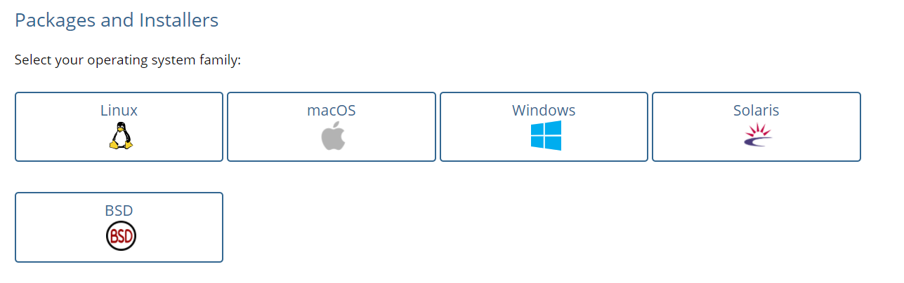

**Step 2 :**  After selecting the version, Download the installer for that particular system.

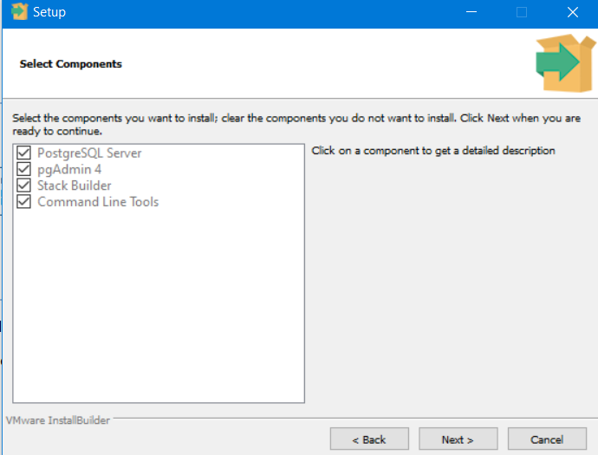**Step 3 :** Follow the steps mentioned in install and click next.

**Step 4 :** Select the components required and click next and do as the installer says.

**Step 5 :** After the installer is finished installing the software. Goto start menu and open **pgadmin4** and PostgresSql will start on localhost.

**b) Compare different Databases such as PostgreSQL, Oracle, MySql and Maria DB.**

Ans.

* PostgresSQL

|  |  |
| --- | --- |
| **Advantages** | **Disadvantages** |
| Open source | Not avaiable on all hosts by default |
| Highly expandable | Expandable documentation only available in English |
| Largeley compliant with SQL standard | Comparatively low reading speed |
| Possible to process complex data types |  |
| Flexible full text search |  |
| Creation of own functions, triggers and datatypes etc |  |
| Good language support |  |
| Supports JSON |  |
| Cross Platform |  |

* Oracle

|  |  |
| --- | --- |
| **Advantages** | **Disadvantages** |
| Portability | Very expensive |
| Market presence | Complexity |
| Version changed | Compatibility |
| Back and recovery | Regular maintenence |
| Performance |  |

* MySQL

|  |  |
| --- | --- |
| **Advantages** | **Disadvantages** |
| Easy to work with | Known limitations |
| Feature rich | Reliability issues |
| Secure | Stagnated development |
| Scalable and powerful |  |
| Speedy |  |

* MariaDB

|  |  |
| --- | --- |
| **Advantages** | **Disadvantages** |
| Fastest performance | Select queries are slower |
| Better compression | No replication from normal MYSQL server |
| Flexible storage options | No support for GROUP BY on disk |
| Machine learning integrations | No MySQL protocol support |
| MySQL frontend |  |
| Windows Functions suppport |  |